**Author’s Notes:** (this should not be part of the specifications):

* In order to prepare this document. I have tried to understand the system verilog code placed in git <https://github.com/openhwgroup/core-v-mcu/blob/master/rtl/apb_gpio/rtl/apb_gpio.sv>
* I have created this block diagram using the <https://lucid.app/lucidchart/df5461ff-e4f0-4f5c-a09b-7e8aeeed2a7f/edit?beaconFlowId=96B7DACD40CCA0A9&invitationId=inv_bdd3a7f7-544e-4611-bb61-4264601b3d64&page=0_0#>
* The logic for OUT1, OUT2, OUT3, PIN1, PIN2, PIN3 registers are not supported in the system-verilog code in the git hub.
* The logic for the rising_edge and falling_edge interrupts is not clear in the system verilog code as the RTL is not holding the previous values of inputs.
* The logic for the open drain for the gpio_out port is also not clear for the open drain mode.
* I have copied the register set from the kshitij’s document. Need to check if we can make it better.

**APB_GPIO** The General Purpose Input/Output (GPIO) IP block supports S/W access to read and write the values on selected I/O, and configuring selected I/O to generate interrupts.

**Features**

* 32-bit bits of user-selectable I/O.
* I/O can be configured for level type interrupts or edge triggered interrupts.

**Theory of Operation** Block diagram of APB_GPIO peripheral:

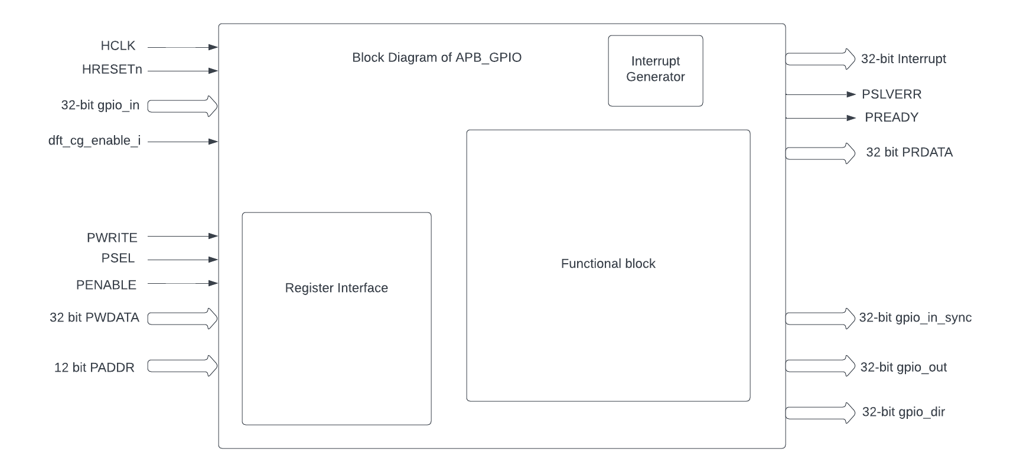

The GPIO module supports a range of configuration options and various types of interrupts.

**Pin Direction and Mode:**

* Input Mode: Configures the pin to read external digital signals into the registers .
* Output Mode: Sets the pin to drive an external digital signal from the registers.

**Interrupts:**

* Edge-Triggered Interrupts: Allows the GPIO pin to generate an interrupt on a rising or falling edge.
* Level-Triggered Interrupts: Generates an interrupt when the pin is at a specified logic level (high or low).

**Programming model**Following FW configurations can be done for the Input mode and Output mode.

* Input mode FW configurations
  + Driving the input ports and reading the register pin values:
    - FW can drive the input pins and these values will be stored in the PIN0 register.
    - FW can also read these input pins of selected GPIOs by reading the PIN0 register.
    - Note: Before reading any register make sure that PSEL, PENABLE are driven to 1 and PWRITE is driven to 0.
  + Driving the input ports and generating an interrupt via outport port:
    - FW can drive the input pins and these values will be stored in the PIN0 register.
    - if the Interrupts are enabled and if the type of the interrupt is also set by FW then the GPIO will accordingly generate/drive that particular output interrupt pin
* Output mode FW configurations
  + Driving the output ports:
    - FW should configure the gpio_dir register correctly.
    - FW can issue a write to any 32 bits of the OUT0 register and that will drive corresponding gpio_num related gpio_out pin
    - it will also drive the gpio_dir output port depending on the values configured in gpio_dir register.
    - Note: Before writing any register make sure that PSEL, PENABLE and PWRITE are driven to 1.
  + Setting the output ports:
    - FW should configure the gpio_dir register correctly.
    - FW can issue a set operation to any 32 bits of the OUT0 register and that will drive corresponding gpio_num related gpio_out pin to value '1'.
    - it will also drive the gpio_dir output port depending on the values configured in gpio_dir register.
    - Note: Before writing any register make sure that PSEL, PENABLE and PWRITE are driven to 1.
  + Clearing the output ports:
    - FW should configure the gpio_dir register correctly.
    - FW can issue a clear operation to any 32 bits of the OUT0 register and that will drive corresponding gpio_num related gpio_out pin to value '0'.
    - it will also drive the gpio_dir output port depending on the values configured in gpio_dir register.
    - Note: Before writing any register make sure that PSEL, PENABLE and PWRITE are driven to 1.
  + Toggling the output ports:
    - FW should configure the gpio_dir register correctly.
    - FW can issue a toggle operation to any 32 bits of the OUT0 register and that will drive corresponding gpio_num related gpio_out pin to toggle w.r.t previous value.
    - it will also drive the gpio_dir output port depending on the values configured in gpio_dir register.
    - Note: Before writing any register make sure that PSEL, PENABLE and PWRITE are driven to 1.
* Read status operation via register.
  + - FW can issue a write to the register SETSEL to select the GPIO number of the pin.
    - FW can issue a read to the RDSTAT register to get all the current operations in GPIO like the mode, PIN0 value, OUT0 value, Interrupt type, Interrupt enable, GPIO number etc.|
    - Note: Before reading any register make sure that PSEL, PENABLE are driven to 1 and PWRITE is driven to 0.

**APB GPIO CSRs**

The GPIO module is typically associated with a set of status and control registers. These registers allow the processor to read input states, set output levels, and configure various GPIO settings.

| **Offset** | **Field** | **Bits** | **Type** | **Default** | **Description** |
| --- | --- | --- | --- | --- | --- |
| 0x00 | SETGPIO | 7:0 | WO |  | Set GPIO[gpio_num] = 1 |
| 0x04 | CLRGPIO | 7:0 | WO |  | Set GPIO[gpio_num] = 0 |
| 0x08 | TOGGPIO | 7:0 | WO |  | Invert the output of GPIO[gpio_num] |
| 0x10 | PIN0 | 31:0 | RO |  | gpio_value[31:0] = GPIO[31:0] |
| 0x14 | PIN1 | 31:0 | RO |  | gpio_value[31:0] = GPIO[63:32] |
| 0x18 | PIN2 | 31:0 | RO |  | gpio_value[31:0] = GPIO[95:64] |
| 0x1C | PIN3 | 31:0 | RO |  | gpio_value[31:0] = GPIO[127:96] |
| 0x20 | OUT0 | 31:0 | WO |  | Drive value[31:0] onto GPIO[31:0] |
| 0x24 | OUT1 | 31:0 | WO |  | Drive value[31:0] onto GPIO[63:32] |
| 0x28 | OUT2 | 31:0 | WO |  | Drive value[31:0] onto GPIO[95:64] |
| 0x2C | OUT3 | 31:0 | WO |  | Drive value[31:0] onto GPIO[127:96] |
| 0x30 | SETSEL | 7:0 | WO | 0x0 | Set gpio_num for use by RDSTAT (Note: SETGPIO, CLRGPIO, TOGGPIO and SETINT set gpio_num) |
| 0x34 | RDSTAT | 25:24 | RO | 0x0 | Read the mode control for GPIO[gpio_num] (set gpio_num using SETSEL) |
|  |  | 19:17 | RO | 0x0 | Type of interrupt for GPIO[gpio_num] |
|  |  | 16:16 | RW |  | Enable interrupt for GPIO[gpio_num] |
|  |  | 12:12 | RO |  | Input value reported by GPIO[gpio_num] |
|  |  | 8:8 | RO |  | Output value that is set on GPIO[gpio_num] |
|  |  | 7:0 | RO |  | Selected gpio |
| 0x38 | SETMODE | 25:24 | WO | 0x0 | Mode control for GPIO[gpio_num] |
|  |  | 7:0 | WO | 0x0 | Address of GPIO to set mode for |
| 0x3C | SETINT | 19:17 | WO | 0x0 | Type of interrupt for GPIO[gpio_num] |
|  |  | 16:16 | WO | 0x0 | Enable interrupt on GPIO[GPIO_ADDDR] |
|  |  | 7:0 | WO | 0x0 | Address of GPIO to set interrupt type and enable for |
| 0x40 | INTACK | 31:8 | RW |  | RESERVED |
|  |  | 7:0 | RW |  | Input value reported by GPIO[gpio_num] |